# 

# 

# 

# **myUCF TRAINING MATERIALS**

### GROUP 5:

### Titionna Batista

### Mark Yanit

### Ellery Hunt

### Danny Acosta Forte

### Juliana Macedo

### Maria Onde SPRING 2022 WEB WORKSHOP II

INTRODUCTION

This documentation provides a detailed guide to utilizing and upgrading the features of the newly designed myUCF site. This redesign strives to provide a user and development friendly interface that is easy to navigate and expand on.

### TABLE OF CONTENTS

### REQUIRED MATERIALS/PROGRAMS UTILIZED……….Page 3

### SETTING UP THE WORKSPACE………..…………Page 4

### UPDATING SITE CONTENT …………………Pages 5-8

### 

### 

### REQUIRED MATERIALS/PROGRAMS UTILIZED

These languages are used throughout the site and will be necessary for any future updates and/or maintenance:

* **HTML** - Used for standard static pages and objects on the site such as divs and content cards.
* **PHP** - Connects the login system and the backend/databases to the site. Additionally modularizes the code through components.
* **JavaScript** - Utilized for the navigation menu in mobile view form and for button responsivity throughout the site.
* **SASS** - Used for styling the overall look of the site and better organization of CSS code.

Note: LiveSASS Compiler on VisualStudio was utilized for faster SASS file compiling. Other compilers may work, but LiveSASS is our team’s recommended extension.

These applications and extensions are necessary for the site to work as intended:

* **XAMPP** or another server to host the site and allow the PHP and MYSQL elements to function
* **MySQL** - Holds the databases needed for student information to be passed through to the site.
* **LiveSASS Compiler** - Highly recommended VisualStudio extension for faster SASS file compiling.
* **WebKit** - For Safari styling to properly comply with the CSS.

Fonts Required:  
Any fonts utilized require an OTF file to properly function with the styling of the site.  
**Gotham** - Main font used throughout myUCF. Styles required are included within the files.

**Helvetica** - Backup font.

### 

### 

### 

### SETTING UP THE WORKSPACE

ACCESSING SITE FILES  
To begin setting up your workspace you will need the files contained on <https://students.cah.ucf.edu/~da400699/dig4172c/> or on [Google Drive](https://drive.google.com/drive/u/0/folders/1m0LvZM4Oa-jq6Y4-6TE_GLEgMOz7Mxxd). Download the folder titled **myUCF/**.

Place the entire folder within the htdocs folder of your XAMPP application. You can test that the files are working by running your localhost and clicking on the MyUCF file within htdocs.

CREATING TO MYSQL DATABASE

The database utilizes MySQL and will be connected to the front end of the site through PHP. The database contains personal information for students featuring their student ID information, classes, and financial information. **“student_enrollment”** connects to student information, while **“courses”** connects to class information. **“student_finances”** connects tofinancial details for the student. The respective information is linked to the individual students through the *“ucfid”* column.

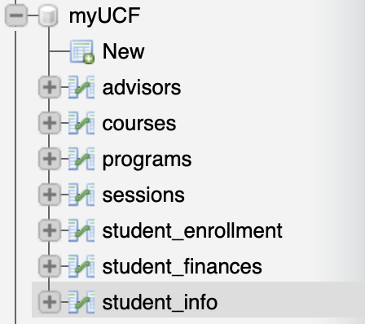

These databases are not included (unless utilizing Google Drive) and will need to be created using a command in MySQL and connected to the site in order for certain features like the login, student information, and class information sections to work. At present the sessions tab only allows one instance of an account to be logged into at a time, so students are not able to look at myUCF from their phone and computer browser simultaneously.

CONNECTING TO MYSQL DATABASE  
  
To connect the database you will need to:

1. Ensure XAMPP is open and that MySQL Database and Apache Web Server are running.
2. Access <http://localhost/phpmyadmin/> in your chosen web browser.
3. Create an empty database titled anything of your choice.
4. Go to the MySQL query command section and copy/paste in the contents of backend/config.php or the Drive Database Files content.
5. Ensure that the database is connected by going into the myUCF file to backend/database/config.php and replace the settings to align with your existing database structure/server architecture.
6. In a default database configuration the username is “root” and no password is required, but we recommend adding a password to ensure information security.

When you open the myUCF link after establishing these settings the site will be able to display information as intended and should initially show the login page.

UPDATING SITE CONTENT

CREATING NEW PAGES  
Pages are located within **their own separate subfolders within the myUCF folder**. Pages contain a standard coding structure that automatically provides the template to comply with styling. To create a new page one can duplicate the code shown in **the finances, my-information, settings, or tasks php files**:

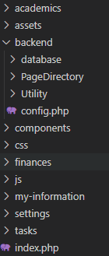

The title of the page can be changed through adjusting the name in the title and h1 of the respective page. To add a page to the navigation the php “include” featured at the top of any aforementioned completed pages must be added before the beginning of any other code within the file.

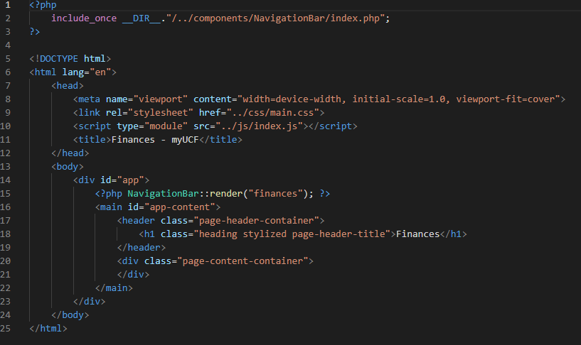

SETTING UP NEW CARDS   
Cards are components nested within their respected subject section within a “components” subffolder. Cards within the academics, finances, or my-information categories utilize database tables to retrieve their contents. Any cards relating to these sections must be included within their respective components folder.

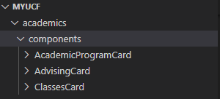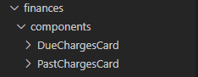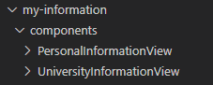

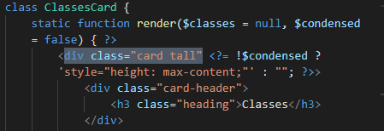

Cards are set to default at one row of height. Placing “tall” at the end of card classes will make the card cover two rows of space.

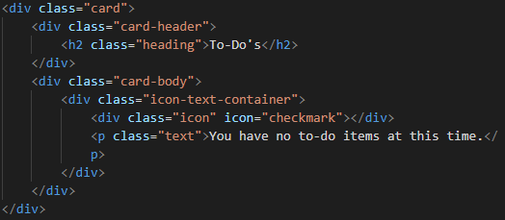

CREATING COMPONENTS

The current non-data related components on myUCF focus on dynamic elements such as the navigation menu, login feedback, and changing the color mode of the site within Settings. Components are housed within their own subfolders under the folder branch and utilize js and php.

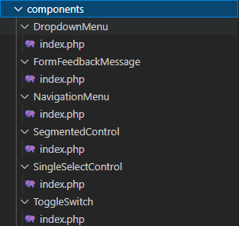

Any new components require their own subfolder and **index.php** file. To feature a component on a page the component must be called before all other code within the file.

